CSCE1040.303 Lab 1 Design Document

# by Mason Besmer

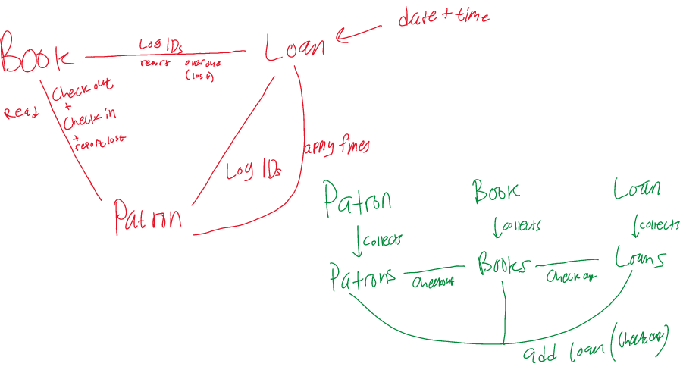

Book

Variables

* Author
* Title
* ISBN Number
* Library ID Number
* Cost
* Current Status (In, out, repair, lost)

Functions

* Get all variables
* Set all variables
* Print function
* Constructor

Pseudocode for Book objects

For all get functions, return the requested variable.

For all set functions, set the variable to the new value.

The print function will print out all the information of a book using the ID number of said book in a nice, pretty way.

The constructor will set default values of the book, if unmodified, so that they aren’t null.

Books

Variables

* All books
* Count of each type (lost, destroyed, checked out, etc.)

Functions

* Print function
* Add Book
* Edit book
* Delete book
* Search for book
* Print single, using search

Pseudocode for Books class

The print function will print out all the information of all books in a nice, pretty way.

Variables of books will be a map of all book objects.

Add book will take a book object and add it to the map.

Edit book will request a book by ID number and change a specified property.

Delete book will delete the book with the specified ID number.

Searching for a book will look up by ID and return requested information on it.

Print single function will run the print function of the specified book object.

Loan

Variables

* Loan ID
* Book ID
* Patron ID
* Due date and time
* Current Loan status

Functions

* Get all variables
* Set all variables
* Print function
* Constructor
* Set status

Pseudocode for Loan objects

For all get functions, return the requested variable.

For all set functions, set the variable to the new value.

The print function will print out all the information of a loan using the ID number of said loan in a nice, pretty way. Includes all ID numbers, and due date.

The constructor will set default values of the loan, if unmodified, so that they aren’t null.

Status function takes a number that corresponds to being overdue or on time and sets itself that way.

Loans

Variables

* All loans
* Count of all loan types
* Loans by date?

Functions

* Check out
* Check in
* List all overdue
* List all for patron
* Update status
* Recheck book
* Edit a loan
* Report as lost

Pseudocode for Loans class

For checking out a book, ensure no overdue books and no more than 5 books currently checked. Create a loan entry with all information.

For checking a book in, ensure fines are properly applied by checking due date (10 days past issue date) and multiplying days over by 25 cents, rounding up to the nearest multiple of 24 hours (2.5 days late =75cent fine). Destroy the loan after finishing, or archive it somehow (not implemented)

In order to recheck a book, edit the loan by looking up the patron by ID and changing due date for the loan.

Reporting a book as lost will need to update patron fine with book fee and change the book status in the database.

Listing all overdue will lookup all overdue loans and print them by ID in a printer friendly list

Patron

Variables

* Name
* ID number
* Fine balance
* Current # of books checked

Functions

* Get all variables
* Set all variables
* Print function
* Constructor
* Status check

Pseudocode for Patrons class

Add patron and generate new ID.

Function to edit patron details, like fines or loans out.

Destroy function to destroy patrons (only allowed if 0 balance and no checked books).

The search function will search patrons using ID number.

Print function specifically to print all patrons and related info.

Print function to print details for one patron using ID search.

PayFine function to apply an amount of money towards a patron’s fine balance

Patrons

Variables

* All patrons
* Patrons in good standing (no fines)
* Patrons ineligible to check books

Functions

* Add
* Edit
* Delete
* Search by ID
* Print list of all
* Print details by ID (using search)
* PayFine

Pseudocode for Patron objects

For all get functions, return the requested variable.

For all set functions, set the variable to the new value.

The print function will print out all the information of a patron using the ID number of said patron in a nice, pretty way.

The constructor will set default values of the patron, if unmodified, so that they aren’t null.

Status check function checks if the patron is eligible to check out a book.

In my design document, I decided on some unusual things to create. Throughout the assignment I added a few functions here and there that I will probably find useful when writing the actual program. In addition, I need to become more efficient with my work when determining a best approach method. I will need to be able to be more flexible with my quality of work if I want to be successful in this class. I decided to be able to have a single main class separate from all of these classes and object files, and wrote my pseudocode accordingly. Once I got the hang of it, I was able to write out everything with ease.